Project Phoenix

Finding Report of AUTH-01 - Weak JWT Signing Secret

Severity: Critical
Week 3 JWT & Token Security · Part B Sprint 1

1. Quick Summary
Finding ID | AUTH-01
What it is | The login token secret key is extremely weak and guessable
Severity | Critical someone can skip login entirely, no password
OWASP | A02 Cryptographic Failures
CWE | CWE-798 Hardcoded Credentials
Affected part | User Service JWT token signing (AUTH_JWT_SECRET)
Branch tested | dev (Hardhat-Enterprises/Phoenix)
Status | Open to be fixed

2. What Is the Problem?
When someone logs in to Phoenix, the system gives them a login token think of it like a wristband at an event. Every time the user does something, they show this wristband and the system lets them in.
To stop people from making fake wristbands, the token is locked with a secret key. The problem is the secret key is just secret123 a value so simple that anyone can guess it in seconds.
Because the key is this weak, anyone can use it to create a fake token and set their role to admin (or anything else). The system will fully trust this fake token. No password needed.

3. How We Tested It
We used only a terminal (CMD) and jwt.io a free website for inspecting tokens. No special tools were needed, which shows how easy this weakness is to exploit.

Step 1 Start the backend
We ran the Phoenix backend using Docker and confirmed all services were up and healthy.
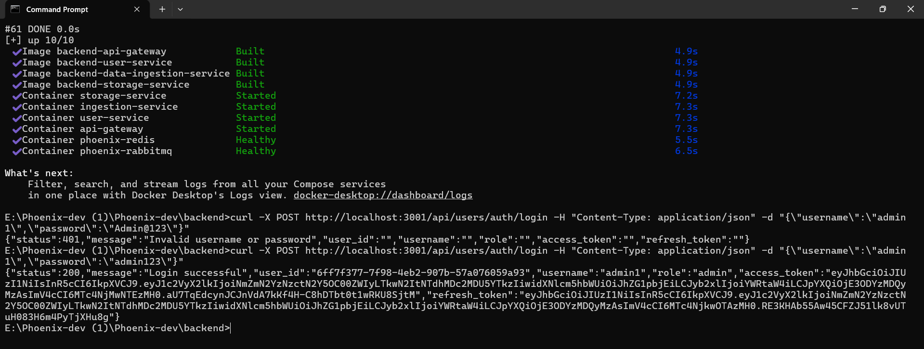

Step 2 Log in and get a real token
We sent a login request using the admin test account:
curl -X POST http://localhost:3001/api/users/auth/login \
-H "Content-Type: application/json" \
-d "{\"username\":\"admin1\",\"password\":\"admin123\"}"
The system returned a status 200 (success), role: admin, and a full access token.

Step 3 Decode the token
We copied the access token into jwt.io to see what it contained. The decoded token clearly shows the algorithm (HS256) and the payload contains the user’s role, ID and the expiration time.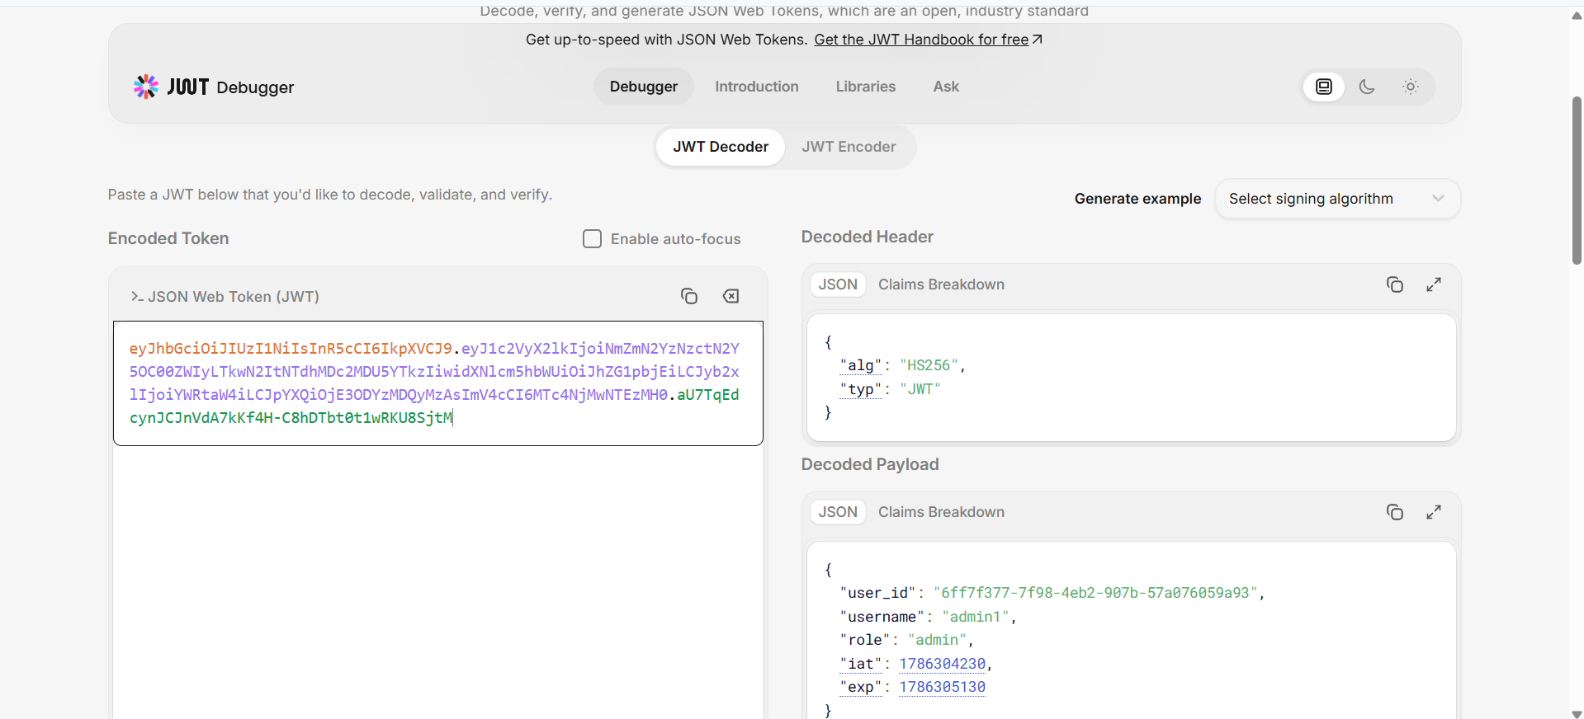

Step 4 Prove the secret key is weak
On the same jwt.io page we typed secret123 into the 'Verify Signature' box. The result:
- Valid JWT ✓
- Signature Verified ✓
- Valid secret ✓
This confirms the system is using secret123 as its signing key. Anyone who knows this can make their own fake tokens.
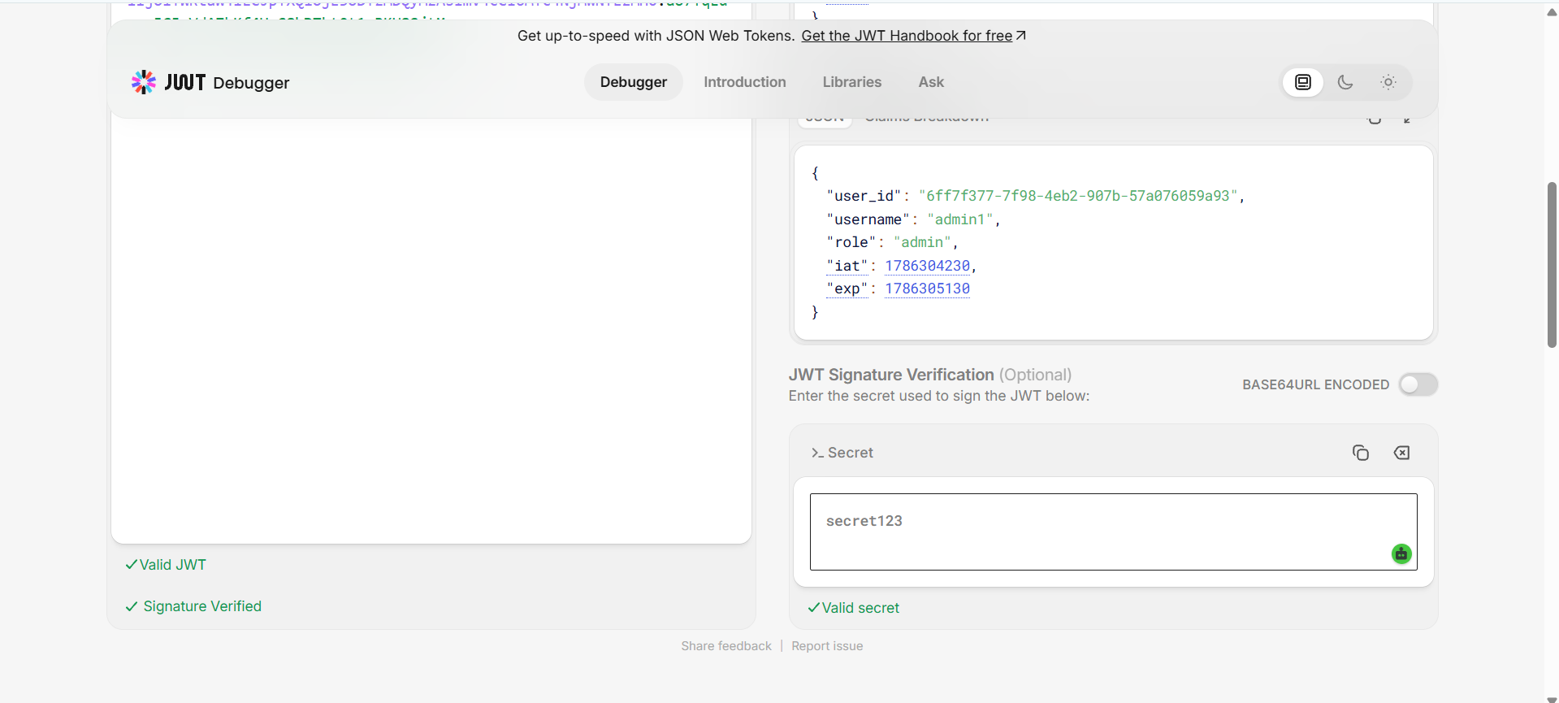

Step 5 Test the token on the live system
We used the token to call a protected endpoint and got a successful response confirming the token works on the running system.
curl -X GET http://localhost:3001/api/users/health \
-H "Authorization: Bearer <token>"
→ {"message":"User service is running"}
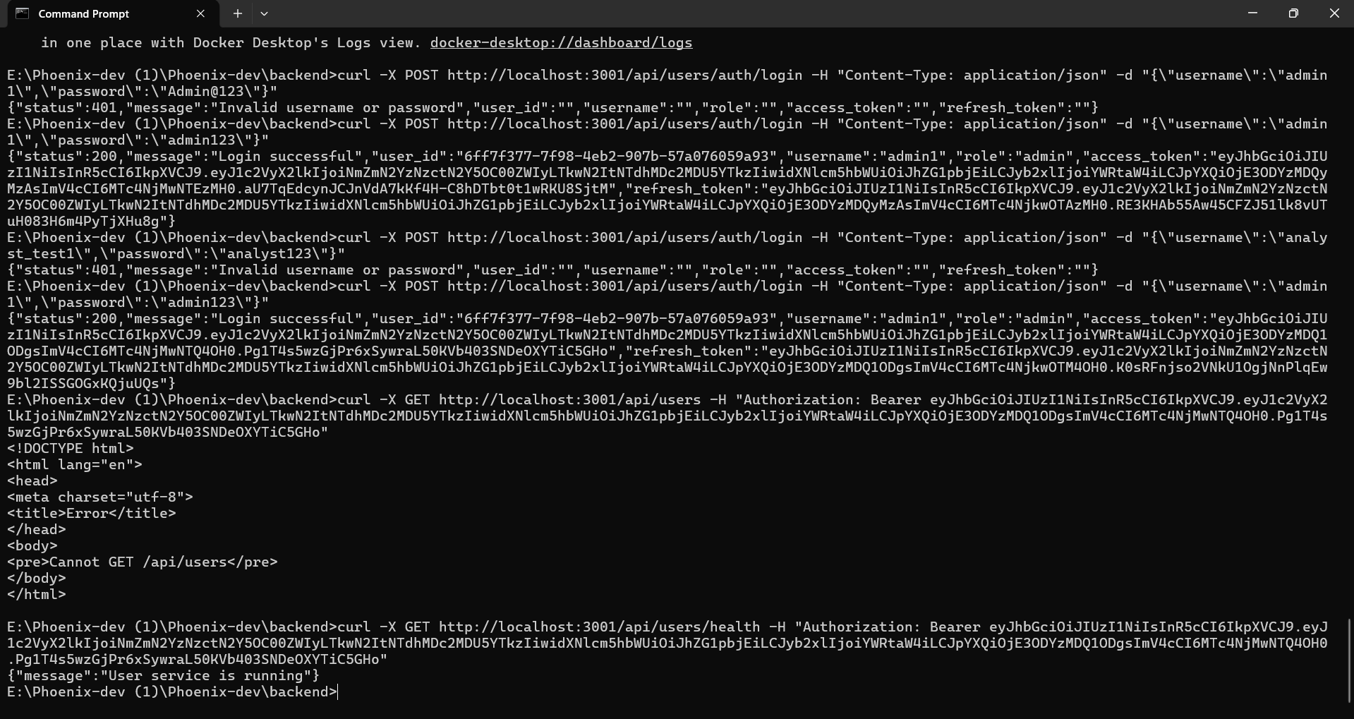

4. How Serious Is This?
Can it be exploited? | Yes - very simple. secret123 can be guessed by hand or cracked in less than a second.
What can an attacker do? | Create fake token with any role ( admin, analyst, etc) and access anything without password.
Do they need special skills? | No. Anyone with jwt.io and basic token knowledge can do this.
Do they need an account? | No, not at all. They can create a token from scratch, no real account needed.
Impact on Phoenix? | Authentication Bypass (Full) Any user or admin can be impersonated by an attacker and get access to all data.

5. Why Did This Happen?
The secret was set to a simple placeholder value in the .env settings file and was never changed to something strong:
AUTH_JWT_SECRET=secret123
AUTH_JWT_REFRESH_SECRET=refreshsecret123
Both the access token secret and the refresh token secret are weak. The .env file was also shared in a team chat, so the secrets are no longer private.

6. How to Fix It
- Immediately change secret123 to a strong random secret (minimum 256 bits)
node -e "console.log(require('crypto').randomBytes(32);Here's the text humanized: toString('hex')
- Never share real secrets in chat, or in a Git repo.
current secret change All existing tokens will be invalidated and everyone will have to login again (which is the safe thing to do).
- add.env and.env.docker to.gitignore so we never accidentally push them to github

7. How This Links to the Rest of Our Review
CFG-01 / CFG-02 (Divjot) | Divjot's config audit already flagged these weak secrets. This test proves they are actively exploitable not just a config concern.
B-02 (Role escalation) | Even if the sign-up role bug was fixed, an attacker can still get admin by forging a token with this weak secret.
RBAC matrix (Muath) | The whole role-based access system depends on the role field in the token being trustworthy. If tokens can be forged, RBAC provides no real protection.
B-03 (Open endpoint) | A forged admin token makes it even easier to exploit any unprotected endpoint.

